User Manual and Project Documentation
Flood Risk Road Analysis Tool
This tool identifies roads near riverbanks and those at risk of flooding using DEM and road data. It calculates the length of each road type (primary, secondary, and tertiary) within these risk zones.
Requirements
- ArcGIS Pro
- Python environment with arcpy installed
- DEM file in .tif format
- Road shapefile in .shp format
Tool Usage Instructions
Input Parameters
- Input DEM (RasterDataset) — Digital Elevation Model in .tif format.
- Input Road Shapefile (FeatureClass) — Road network data in .shp format.
- Output Folder — Directory to save output data.
Steps Performed by the Tool
- Fill DEM
Ensures no depressions in the DEM for accurate flow modeling.
- Calculate Slope
Identifies slope values to determine flat areas.
- Calculate Flow Direction and Flow Accumulation
Flow direction guides the water path; flow accumulation identifies potential river paths.
- Get Flow Accumulation Threshold
Determines threshold values to classify river networks.
- Delineate River
Extracts river networks from flow accumulation data.
- Convert River Raster to Vector
Converts raster-based river data into vector format for better analysis.
- Change Projection System
Chane the projection system of river from geographic to projected.
- Calculate River Buffer (500m)
Expands the river area by 500m to mark potential flood zones.
- Convert River Buffer to Raster
Creates a raster dataset representing the riverbank region.
- Extract Flat Riverbank Areas
Identifies regions with slopes < 20 degrees near the riverbank.
- Road Data Processing
Creates a buffer for roads.
Converts road buffer to raster format.
- Risk Zone Identification
Intersects road raster with:
Riverbank raster (for roads near riverbanks)
Flat riverbank raster (for roads at flood risk)
- Convert Raster to Polygon
Converts identified road risk zones into polygons for further analysis.
- Length Calculation for Road Types
Dissolves polygons by road type (primary, secondary, tertiary).
Calculates the length of each road type using:
Add Field (to prepare for length data)
Update Cursor (to populate length field)
Search Cursor (to extract and print final lengths)
Output Data
Map of Roads at Riverside (Vector Polyline) with the total length of primary, secondary, and tertiary roads near riverbanks.
Map of Roads at Risk (Vector Polyline) with the total length of primary, secondary, and tertiary roads that are risk of flooding.
Input Dataset: DEM (.tif) and road (.shp)
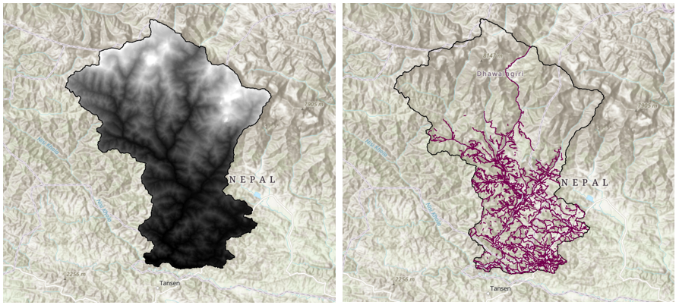
Output map: Roads near riverbank (.shp), and roads risk of flooding (.shp)
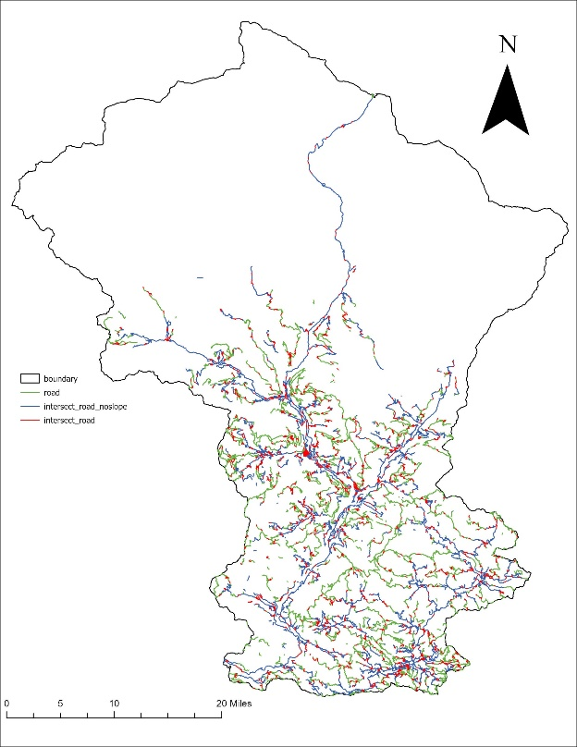
Output table: Length of each type of road
